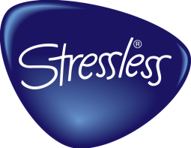

New: Height options for Stressless® sofas with steel round leg / wooden round leg
PUBLISHED 9/11/2015
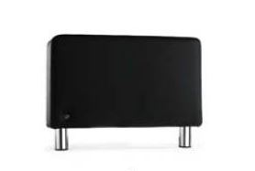
​As from September 1st 2015, we will make three heights available on sofas delivered with the round legs. These legs are used on models Stressless E200, Stressless E300, Stressless Arion and Stressless Wave.
When ordering any of this product PLEASE specify which leg size you desire. If you use the old sku from the price book, you will receive the new lower (80mm).
001= Steel round leg (80 mm) = 3.15 Inches
011= Steel round leg (110 mm)= 4.33 Inches
012= Steel round leg (140 mm)= 5.51 inches
006= Wood round leg (80 mm)= 3.15 Inches
015= Wood round leg (110 mm)= 4.33”
016= Wood round leg (140 mm)= 5.51 “
MC/SC/SCA setups
The Stressless Arion armrest is lower than the Wave armrest, so MC, SC and SCA on Stressless Arion have higher legs than the armrests. Stressless Arion setups with Medium Corner, Sector and Sector Arm are therefore not available with 140 mm leg height. This does not apply to Stressless Wave, where leg height is the same for armrest and MC/SC/SCA.
MC/SC/SCA will automatically get the correct height corresponding to the legs you choose for the armrests, both for Stressless Arion and Wave.

